**EAST WEST UNIVERSITY**

**CSE438**

**Section: 01**

**Lab: 03 Report**

**Topic: Match the reference image using histogram matching**

**Submitted By:**

**Name: Md Sifat Ullah Sheikh**

**ID: 2022-1-60-029**

**Submitted To:**

**K.M. Safin Kamal**

**Lecturer**

**Department of Computer Science & Engineering**

**Date: 14 July 2025**

**Q1.** Adjust the histogram of the following image to match the reference image using histogram matching. Show the histogram of original, reference, and output images.

**CODE:**

import cv2

import matplotlib.pyplot as plt

from skimage.exposure import match_histograms

src_path = '/kaggle/input/cse-438-lab-03/CSE_438_LAB_03/Picture3.png'

ref_path = '/kaggle/input/cse-438-lab-03/CSE_438_LAB_03/Picture4.png'

src_rgb = cv2.cvtColor(cv2.imread(src_path), cv2.COLOR_BGR2RGB)

ref_rgb = cv2.cvtColor(cv2.imread(ref_path), cv2.COLOR_BGR2RGB)

matched_rgb = match_histograms(src_rgb, ref_rgb, channel_axis=-1)

def plot_rgb_histogram(image, ax, title):

color = ('r', 'g', 'b')

for i, col in enumerate(color):

hist = cv2.calcHist([image], [i], None, [256], [0,256])

ax.plot(hist, color=col)

ax.set_title(title)

ax.set_xlim([0, 256])

ax.set_xlabel('Pixel Value')

ax.set_ylabel('Frequency')

plt.figure(figsize=(18, 5))

titles = ['Source Image', 'Reference Image', 'Matched Image']

images = [src_rgb, ref_rgb, matched_rgb]

for i in range(3):

plt.subplot(1, 3, i+1)

plt.imshow(images[i])

plt.title(titles[i])

plt.axis('off')

plt.tight_layout()

plt.show()

fig, axes = plt.subplots(1, 3, figsize=(18, 4))

hist_titles = ['Source Histogram', 'Reference Histogram', 'Matched Histogram']

for i, ax in enumerate(axes):

plot_rgb_histogram(images[i], ax, hist_titles[i])

plt.tight_layout()

plt.show()

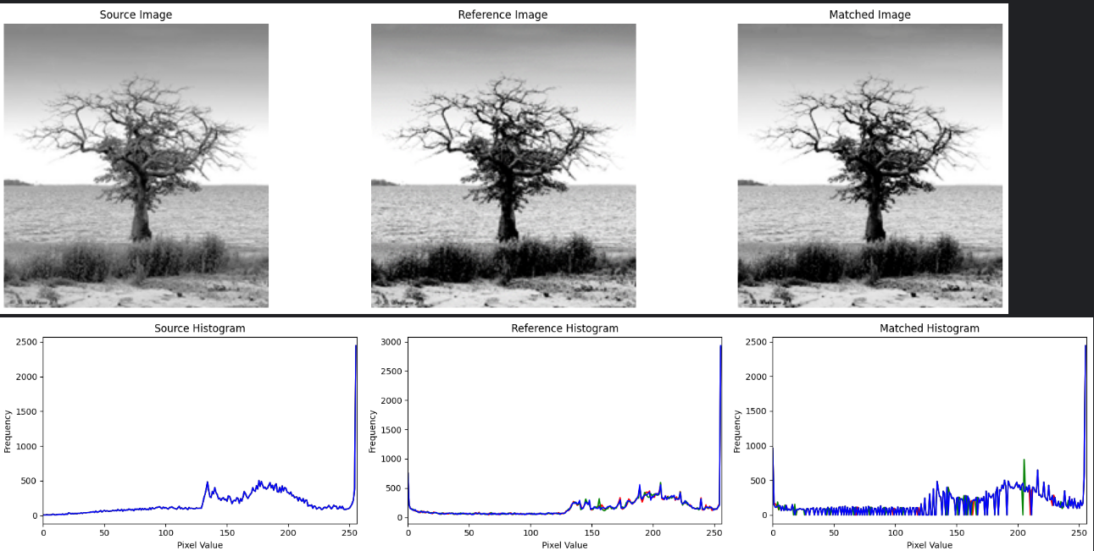

import cv2

import matplotlib.pyplot as plt

from skimage.exposure import match_histograms

src_path = '/kaggle/input/cse-438-lab-03/CSE_438_LAB_03/Picture3.png'

ref_path = '/kaggle/input/cse-438-lab-03/CSE_438_LAB_03/Picture4.png'

src_rgb = cv2.cvtColor(cv2.imread(src_path), cv2.COLOR_BGR2RGB)

ref_rgb = cv2.cvtColor(cv2.imread(ref_path), cv2.COLOR_BGR2RGB)

matched_rgb = match_histograms(src_rgb, ref_rgb, channel_axis=-1)

def plot_rgb_histogram(image, ax, title):

color = ('r', 'g', 'b')

for i, col in enumerate(color):

hist = cv2.calcHist([image], [i], None, [256], [0,256])

ax.plot(hist, color=col)

ax.set_title(title)

ax.set_xlim([0, 256])

ax.set_xlabel('Pixel Value')

ax.set_ylabel('Frequency')

plt.figure(figsize=(18, 5))

titles = ['Source Image', 'Reference Image', 'Matched Image']

images = [src_rgb, ref_rgb, matched_rgb]

for i in range(3):

plt.subplot(1, 3, i+1)

plt.imshow(images[i])

plt.title(titles[i])

plt.axis('off')

plt.tight_layout()

plt.show()

fig, axes = plt.subplots(1, 3, figsize=(18, 4))

hist_titles = ['Source Histogram', 'Reference Histogram', 'Matched Histogram']

for i, ax in enumerate(axes):

plot_rgb_histogram(images[i], ax, hist_titles[i])

plt.tight_layout()

plt.show()

**Q2.** Change the contrast of the image using histogram equalization. Show the histogram of both input and output images.

**CODE**

import cv2

import matplotlib.pyplot as plt

img_path = '/kaggle/input/cse-438-lab-03/CSE_438_LAB_03/Picture5.png'

img_bgr = cv2.imread(img_path)

img_ycrcb = cv2.cvtColor(img_bgr, cv2.COLOR_BGR2YCrCb)

y, cr, cb = cv2.split(img_ycrcb)

y_eq = cv2.equalizeHist(y)

img_ycrcb_eq = cv2.merge([y_eq, cr, cb])

img_bgr_eq = cv2.cvtColor(img_ycrcb_eq, cv2.COLOR_YCrCb2BGR)

img_rgb = cv2.cvtColor(img_bgr, cv2.COLOR_BGR2RGB)

img_rgb_eq = cv2.cvtColor(img_bgr_eq, cv2.COLOR_BGR2RGB)

plt.figure(figsize=(12, 5))

plt.subplot(1, 2, 1)

plt.imshow(img_rgb)

plt.title('Original Color Image')

plt.axis('off')

plt.subplot(1, 2, 2)

plt.imshow(img_rgb_eq)

plt.title('Equalized Color Image')

plt.axis('off')

plt.tight_layout()

plt.show()

# Save the equalized color image

cv2.imwrite('/kaggle/working/color_equalized_image.png', img_bgr_eq)

print("✅ Color equalized image saved at: /kaggle/working/color_equalized_image.png")

def plot_rgb_hist(image, ax, title):

colors = ('r', 'g', 'b')

for i, col in enumerate(colors):

hist = cv2.calcHist([image], [i], None, [256], [0, 256])

ax.plot(hist, color=col)

ax.set_title(title)

ax.set_xlim([0, 256])

ax.set_xlabel("Pixel Value")

ax.set_ylabel("Frequency")

fig, axs = plt.subplots(1, 2, figsize=(14, 4))

plot_rgb_hist(img_rgb, axs[0], "Original RGB Histogram")

plot_rgb_hist(img_rgb_eq, axs[1], "Equalized RGB Histogram")

plt.tight_layout()

plt.show()

cv2.imwrite('/kaggle/working/color_equalized_image.png', img_bgr_eq)

print("✅ Color equalized image saved at: /kaggle/working/color_equalized_image.png")

